Whilst the software for the fridge is being developed we also have to think about the design of the interface. The project will require two interfaces to be designed, one for the data visualisation that’s presented through an online cloud once data is collected from multiple fridges and one interface that is for the individual user of each fridge to scan in products, view inventory and so on.

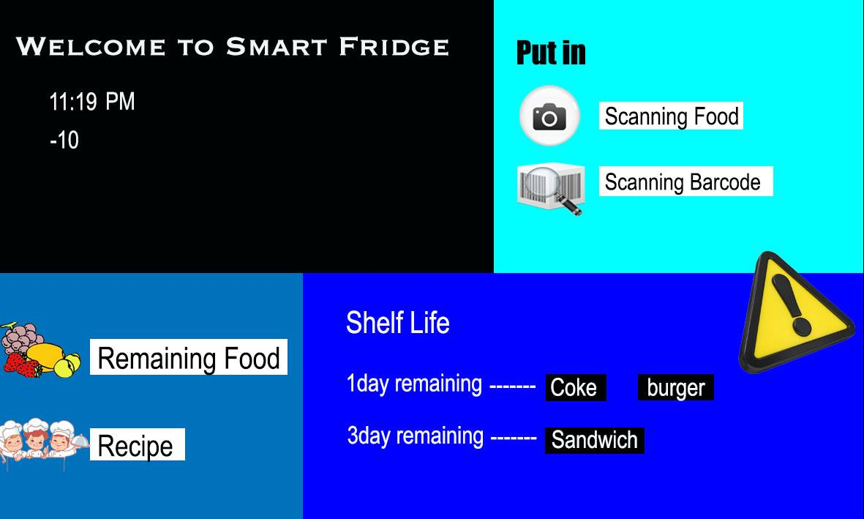The first stage of designing the interface was to think of what features the fridge had and think of the flow of the user experience. As the fridge is designed specifically to be simplistic to the user, we wanted to have the few features that the fridge offers all displayed on the landing screen rather than making the user have to navigate through menu’s to find things. We wanted to design this interface based around the kind of simplicity you’d find on a self service checkout but also in a popular tile fashion that you might find in an operating system such as windows 10. Designing the interface with the simplicity of a self service checkout makes obvious sense as they’re both based around scanning food products.

This raises the issue of whether or not the user is going to want to use the fridge if they’re having to scan multiple food products as if they’re working on a checkout themselves. However, for a start these interfaces are designed to be easy to use as there is no specific audience for super markets as they’re aimed at everyone from old age pensioners down to children. I’d argue against people not using the fridge for the sake of not wanting to scan their food products. Although yes, there will be a large number of people who’d be against this, I feel as though in general people who choose to use the fridge will be choosing to because they care about their healthy eating habits. This could be people of various ages from the elderly looking to stay healthy, young adults and students, but also people such as parents who want to make sure their family are eating healthily and people looking to improve their health. I feel as though our audience would be willing to sacrifice a small amount of time scanning food for the sake of their health. A good example of this is the My Fitness Pal app which has over 50 million downloads on the google play store alone[1]. This app works by the user setting a daily calorie count and scanning each food item they want to eat, the app can then therefore tell them whether or not they can eat the food or whether it will take them over their daily calorie count.

The first phase design of the interface acted as a wireframe. From this we confirmed that we wanted to run off of a basic tile design and it helped us to decide which features we needed to include on the landing page. However in terms of visual aesthetic it needed a lot of work due to layout of the tiles, colour, font and general overall aesthetic. With the 2nd iteration of the interface design we’ve made it looked a lot sleeker using a more modern use of blacks, greys and whites, transparency and a background lying underneath the transparent menu window. We’ve also made it even simpler to use compared to the first iteration by keeping the functionality mostly entirely in the landing page. This is done by having the functions displayed on the left as buttons and then the right side of the screen will be the “action” area where the function is being used to carry out functions such as scanning a product, looking at recipes and viewing your inventory.

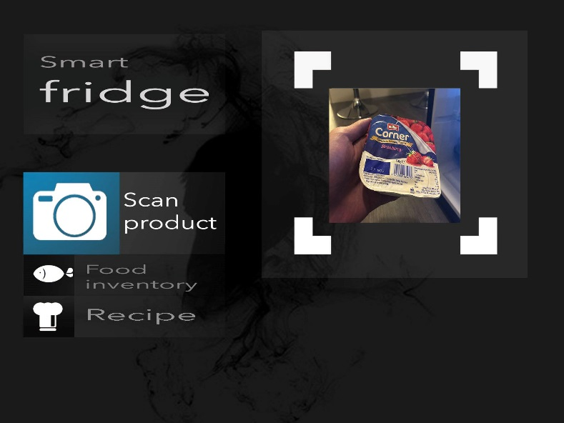

Personally I believe that a good interface doesn’t need to be designed to look and feel more complicated than it needs to be just for the sake of it coming across as more advanced. However, aesthetic is extremely important and we still need to make adjustments such as minor positioning, text and also considering things such as animation and transition of buttons. We also need to consider how the function area will work for each function. Although we don’t need to over complicate the interface, I also believe that an interface should display certain functions relating to its purpose. Saying this, I feel as though the interface could benefit from toolbar including basic functions such as a clock, calendar. Also in a more advanced version we may want to include tools such as being able to adjust the temperature of the fridge and have a temperature display. However, in this experimental instance of the fridge this is not necessary towards the function and purpose of what we are trying to achieve.

1. Google play store, MyFitnessPal Inc, November 2018.